Functional Interfaces and Lambda Expressions :

Functional Interfaces are the newly addition to the Java 8 which can define only one abstract method inside that interface. These interfaces can be represented as Lambda Expression as there is no other methods to be implemented. We can define multiple default and static methods in the Functional Interface.
Examples of functional interfaces in Java include:
- Runnable (with void run())
- Callable<T> (with T call())
- Comparator<T> (with int compare(T o1, T o2))

We can instantiate an interface by using the Anonymous class but the code looks like bulky. Instead of doing like this, we can use of Lambda Expression.

package com.java8;

public class ClientTest {

public static void main(String[] args) {

//System.out.println("hi");
//createThreadUsingAnonymousClass();
System.out.println(Thread.currentThread().getName());
createThreadUSingLambdaExpression();

}

private static void createThreadUSingLambdaExpression() {

Runnable r = ()->
{
System.out.println(Thread.currentThread().getName()+" Thread is executing...");
};
Thread t= new Thread(r);
t.start();

}

private static void createThreadUsingAnonymousClass() {
Runnable r = new Runnable() {

@Override
public void run() {

System.out.println(Thread.currentThread().getName()+" is executing....");
}
};
Thread t = new Thread(r);
t.start();
}

}

Key Points of Functional Interface :

- Functional Interface is also called Single Abstract Method Interface (SAM Interface).
- The interface can also declare the abstract methods from the java.lang.Object class, but still the interface can be called as a Functional Interface.
- Once you add another abstract method in the Functional Interface, then it will throw error.
- Interface can extend another interface and in case the interface it is extending a functional interface and it doesn’t declare any new abstract method then the new interface is also Functional Interface.
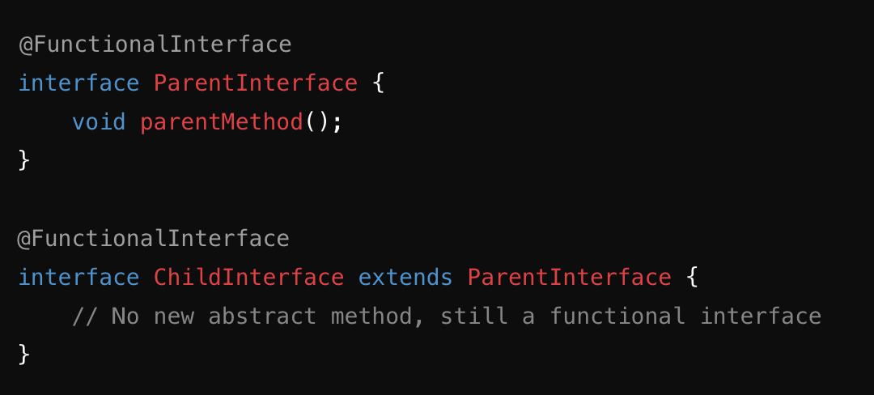
- FunctionalInterface can consist of
  - one abstract method
  - Multiple default methods
  - Multiple Static methods
  - Object class methods - Any method in a functional interface that matches a method in java.lang.Object (such as toString(), equals(), or hashCode()) is not considered an abstract method. Therefore, an interface can still be a functional interface even if it overrides a method from the Object class.
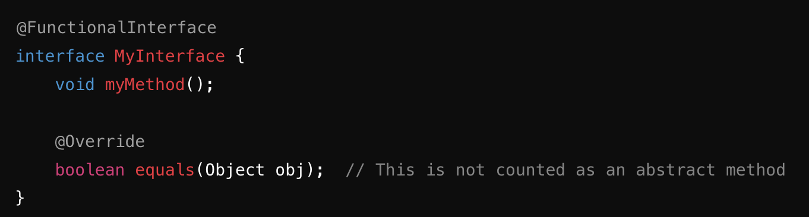
- @FunctionalInterface annotation is used to ensure an interface can’t have more than one abstract method. The use of this annotation is optional.
- The java.util.function package contains many builtin functional interfaces in Java 8.

@FunctionalInterface
Public interface MyInterface
{
public abstract void method1();
public abstract int hashCode();
public boolean equals(Object obj);
}

What are some of the predefined functional interfaces in Java 8?
Answer: Java 8 introduced several predefined functional interfaces in the java.util.function package, including:
- Predicate<T>: Represents a boolean-valued function of one argument. (boolean test(T t))
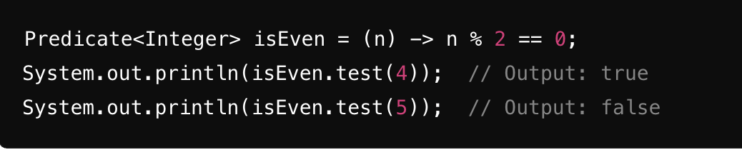

- Function<T, R>: Represents a function that takes one argument and produces a result. (R apply(T t))
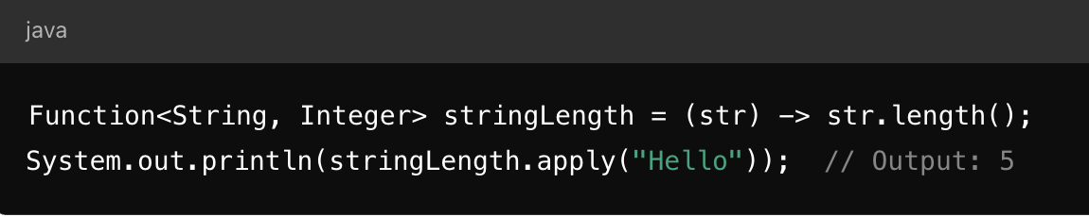

- Consumer<T>: Represents an operation that accepts a single input argument and returns no result. (void accept(T t))

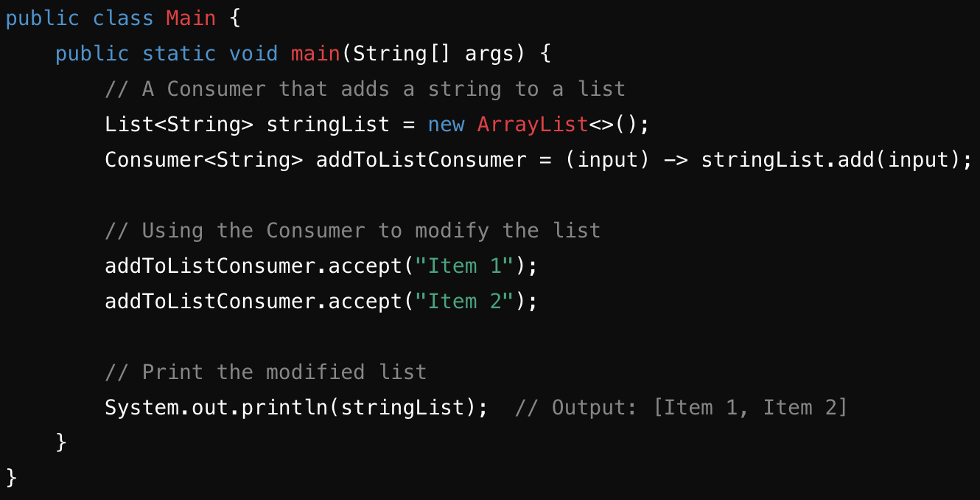

- Supplier<T>: Represents a supplier of results with no input argument. (T get())

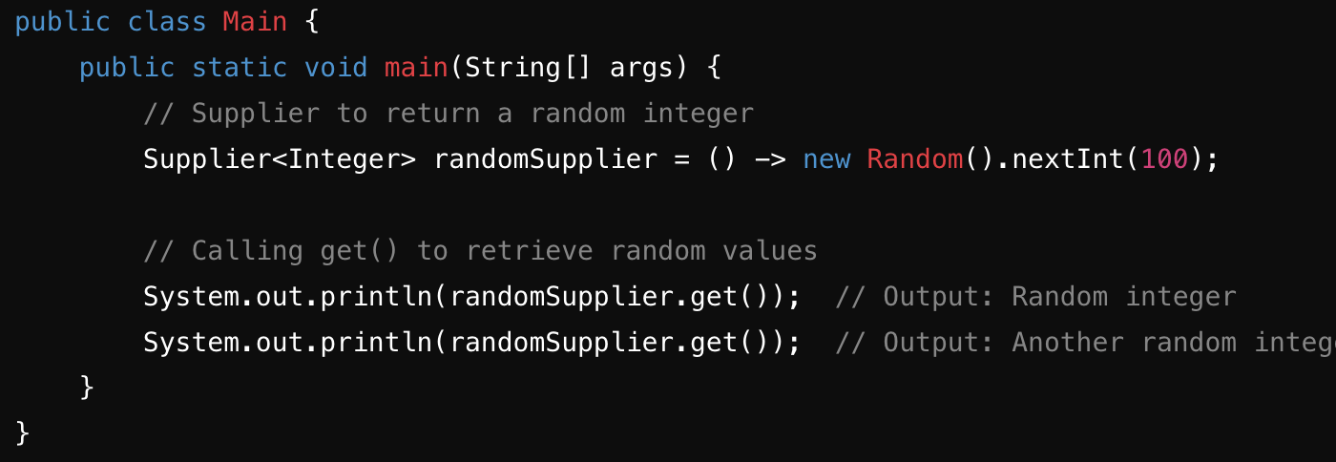

- BiFunction<T, U, R>: Represents a function that takes two arguments and produces a result. (R apply(T t, U u))
- UnaryOperator<T>: A specialization of Function<T, T> that takes one argument and returns a result of the same type.
- BinaryOperator<T>: A specialization of BiFunction<T, T, T> for binary operations on the same type.

What is the use of andThen() and compose() methods in the Function<T, R> interface?

andThen(Function after): This method is used to chain another function to be executed after the current function. The output of the current function is passed as input to the next function.

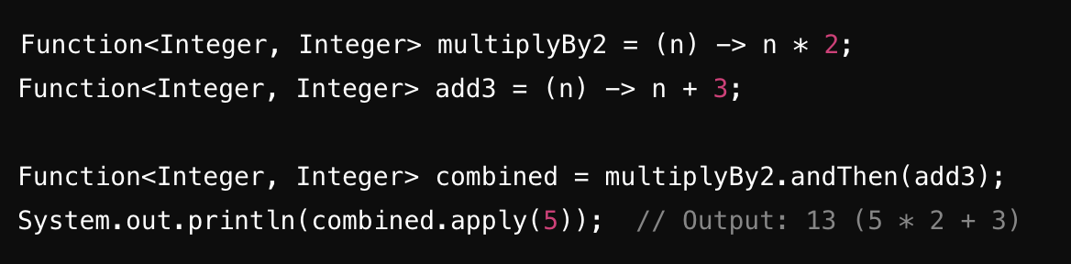

compose(Function before): This method is used to apply a function before the current function. The output of the given function is passed as input to the current function.

